**Assignment 2 - online forum**

Name: ZitingWang

StudentID: 20082254

# Overview

This Vue projec This forum supports add, delete, modify, and like features. When the user enters the main page, you can see the list of posts, but if you want to post, you need to log in before you can post. Login users can log in using facebook, Google, and email.

t can perform all the operations inside assignment1 on the webpage, such as adding, modifying, deleting and finding. At the same time, by using api and firebase, users can also view Google Maps and log in using Google account, email, etc.

api: google map

facebook login

google login

firebase

# Functions

* 1. Posts list

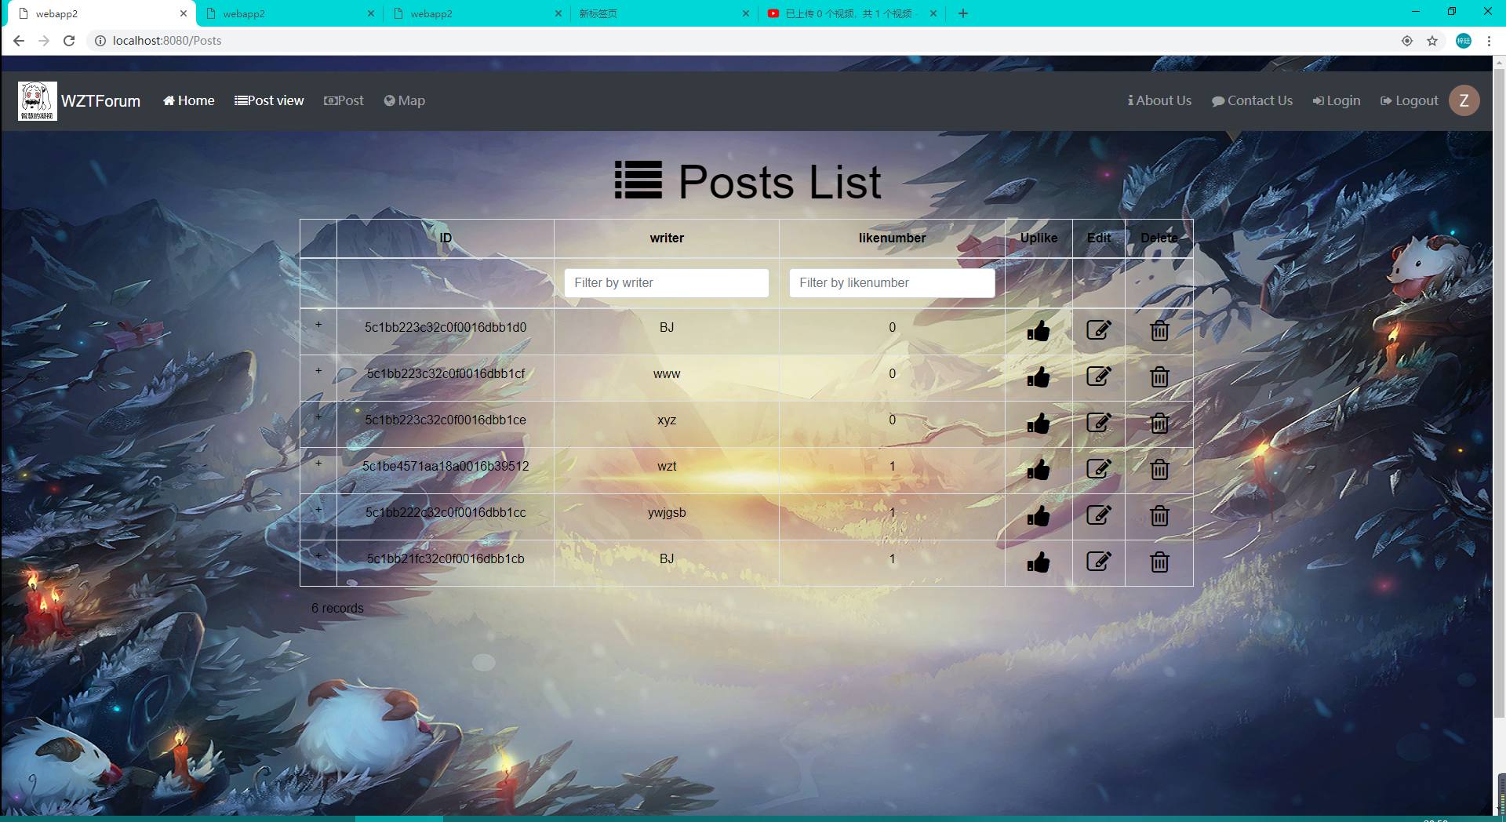

* 1. Post a post

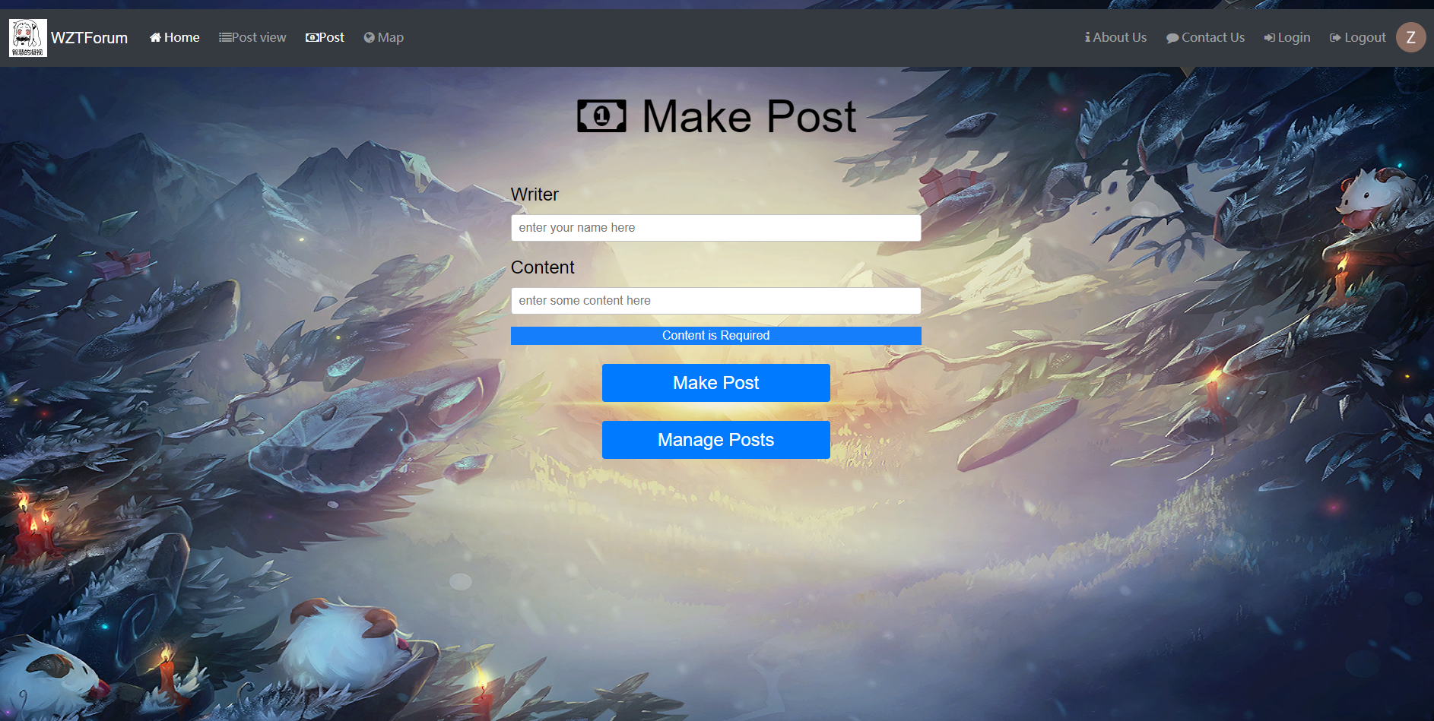

* 1. Uplike edit delete



* 1. Login



* 1. Google map

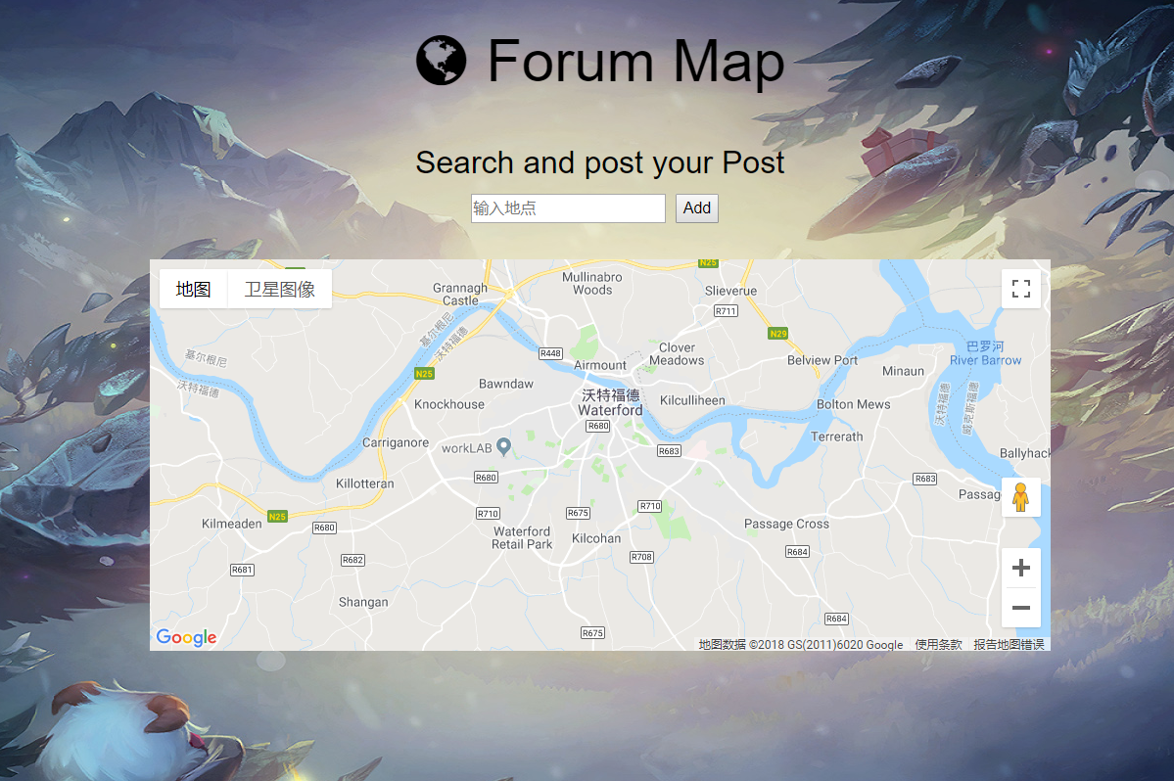

# Use Case Diagram



# Repository and Deployment

1. Github

Client: <https://github.com/ZitingWang/Vuedd>

1. URL of the deployed Web API

https:// webapp-ziting.herokuapp.com/

1. URL of the auto-deployed Vue app(surge)

<http://wztgandd.surge.sh>

1. URL of the deployed Vue app(firebase)

https://webapp-2ce3f.firebaseapp.com

1. Continuous Integration.

Server：<https://travis-ci.org/ZitingWang/webapp2>

Client: <https://travis-ci.org/ZitingWang/Vuedd>

YOUTUBE LINK: https://youtu.be/2eI4Qol903M